**Spiceworks** is an online community where IT professionals collaborate, seek advice, and engage in a marketplace for IT-related services and products. [It’s estimated to be used by over six million IT pros and 3,000 technology vendors1](https://en.wikipedia.org/wiki/Spiceworks).

Here are **five free learning resources** you can explore to enhance your IT knowledge:

1. **Microsoft Learn**: Master core concepts at your own pace through interactive modules and paths.





1. **Edx**: Access free online courses from top universities like Harvard, Google, and Amazon.

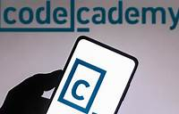

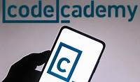

1. **Codecademy**: Learn coding and scripting skills to automate tasks.





1. [**Spiceworks Community Training Resources**](https://community.spiceworks.com/t/free-online-training-resources/366692): Discover various IT-related courses and discussions within the Spiceworks community.
2. [**Inspired eLearning Free Resources**](https://community.spiceworks.com/t/tons-of-free-resources-from-inspired-elearning/935660): Access videos, e-books, infographics, and more to keep cybersecurity knowledge fresh.

Happy learning! 🚀👩‍💻